**PROGRAMMING IN JAVA**

**EXPERIMENT:- 1.1**

**Student Name: Neha Sharma UID: 20BCS4576**

**Branch: CSE-IOT Section/Group: A**

**Semester: 3RD Date of Performance: 20/08/2021**

**Subject Name: Programming in Java lab**

**Subject Code: 21O-20CSP-235_20BIT-1_A**

**1. Aim/Overview of the practical:**

Write a Java program that prints all real solutions to the quadratic equation ax2+bx+c = 0. Read in a, b, c and use the quadratic formula. If the discriminate b2-4ac is negative, display a message stating that there are no real solutions**.**

**2. Task to be done:-** In the above program, the coefficients a, b, c, Then, The ‘D’ calculate as =

b^2 – 4ac. Based on the ‘D’ the roots are calculate as given in the formula above.

**3. Algorithm/Flowchart (For programming based labs):**

Step 1. Start

Step 2. Take input from user as the value of a, b, c.

Step 3. Calculate D = b*b-4*a*c

Step 4. Check condition if(div>0)

Step 5. Then calculate and display root1= “root1+”\nroot2=” +root2

Step 6. If div = 0 then calculate root1=root2= -b/(2*a) and display root1=root2” + root1

Step 7. If no one condition is true then display roots are imaginary.

Step 8. End the program.

**4. Theme/Interests definition ( For creative domains):** No

**5. Code:-**

import java.util.Scanner;

public class SquareRoot {

public static void main(String args[]) {

int a, b, c, div;

double root1, root2;

System.out.print("enter the value of a : ");

Scanner input = new Scanner(System.in);

a=input.nextInt();

System.out.println();

System.out.print("enter the value of b : ");

input = new Scanner(System.in);

b=input.nextInt();

System.out.println();

System.out.print("enter the value of c : ");

input = new Scanner(System.in);

c=input.nextInt();

div=b*b-4*a*c;

if(div>0){

root1 = -b + Math.sqrt(div)/ (2 * a);

root2 = -b - Math.sqrt(div)/ (2 * a);

System.out.println("root1= "+root1 +"\nRoot2=" +root2);

}

else if(div==0){

root1=root2= -b/(2*a);

System.out.println("root1=root2" +root1);

}

else{

System.out.println("roots are imaginary");

}

}

}

**6. Result/Output/Writing Summary:**

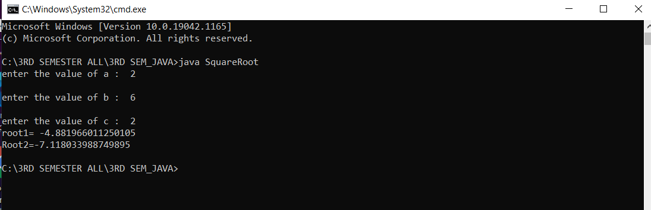

**Learning outcomes (What I have learnt):**

1. **To learn how to implement object-oriented design with java.**
2. **Understand programming basics.**
3. **To learn how to read and write files in java.**

**4. To learn how to calculate the square root with java language.**

**5. Display output on CMD.**

**Evaluation Grid (To be created as per the SOP and Assessment guidelines by the faculty):**

|  |  |  |  |
| --- | --- | --- | --- |
| Sr. No. | Parameters | Marks Obtained | Maximum Marks |
| 1. |  |  |  |
| 2. |  |  |  |
| 3. |  |  |  |
|  |  |  |  |